**Data Base Management System**

Assignment – 2

Name: Ashutosh Soni

Id: 2018ucp1505

Q1: Create a table named Employee (Emp_id int, First_name varchar (20), Last_name varchar (20), Email varchar (20), Address varchar (50), City varchar (15)) with no primary key. Insert 10 rows of data in the Employee table.

Ans:

Query: -

CREATE TABLE Employee (

Emp_id int,

First_name varchar (20),

Last_name varchar (20),

Email varchar (20),

Address varchar (50),

City varchar (50)

);

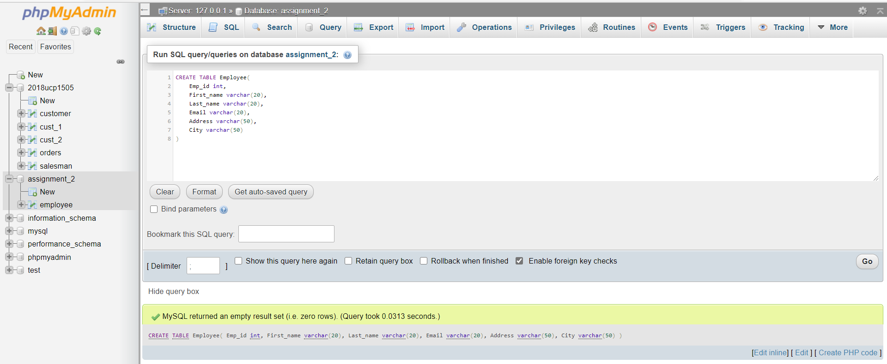

Q2: WAQ to change "Email" column from varchar (20) to varchar (30).

Ans:

Query: -

ALTER TABLE Employee

MODIFY Email varchar (30);

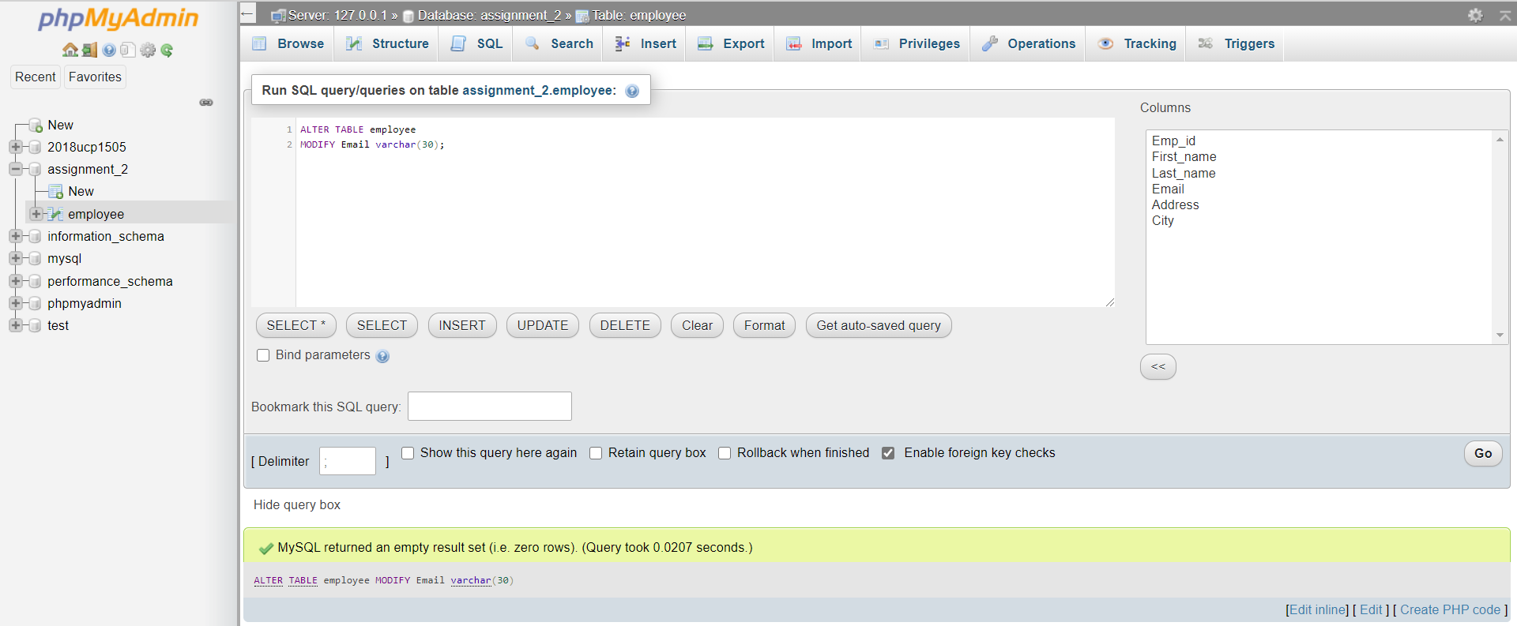

Q3: WAQ to add a new column "DOJ" in the Employee table which stores the date on which the employee joined the company. DOJ column should allow NULL values

Ans:

Query: -

ALTER TABLE Employee

ADD COLUMN DOJ date;

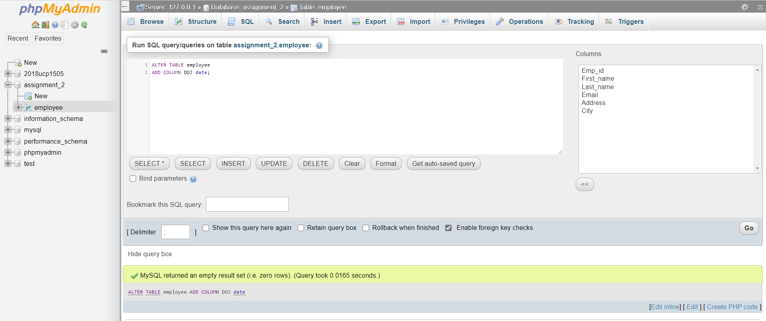

Q4: WAQ to add a new column "DOB" in the Employee table which stores the date of birth of the employee. DOB column should not allow NULL values.

Ans:

Query: -

ALTER TABLE Employee

ADD COLUMN DOB date NOT NULL;

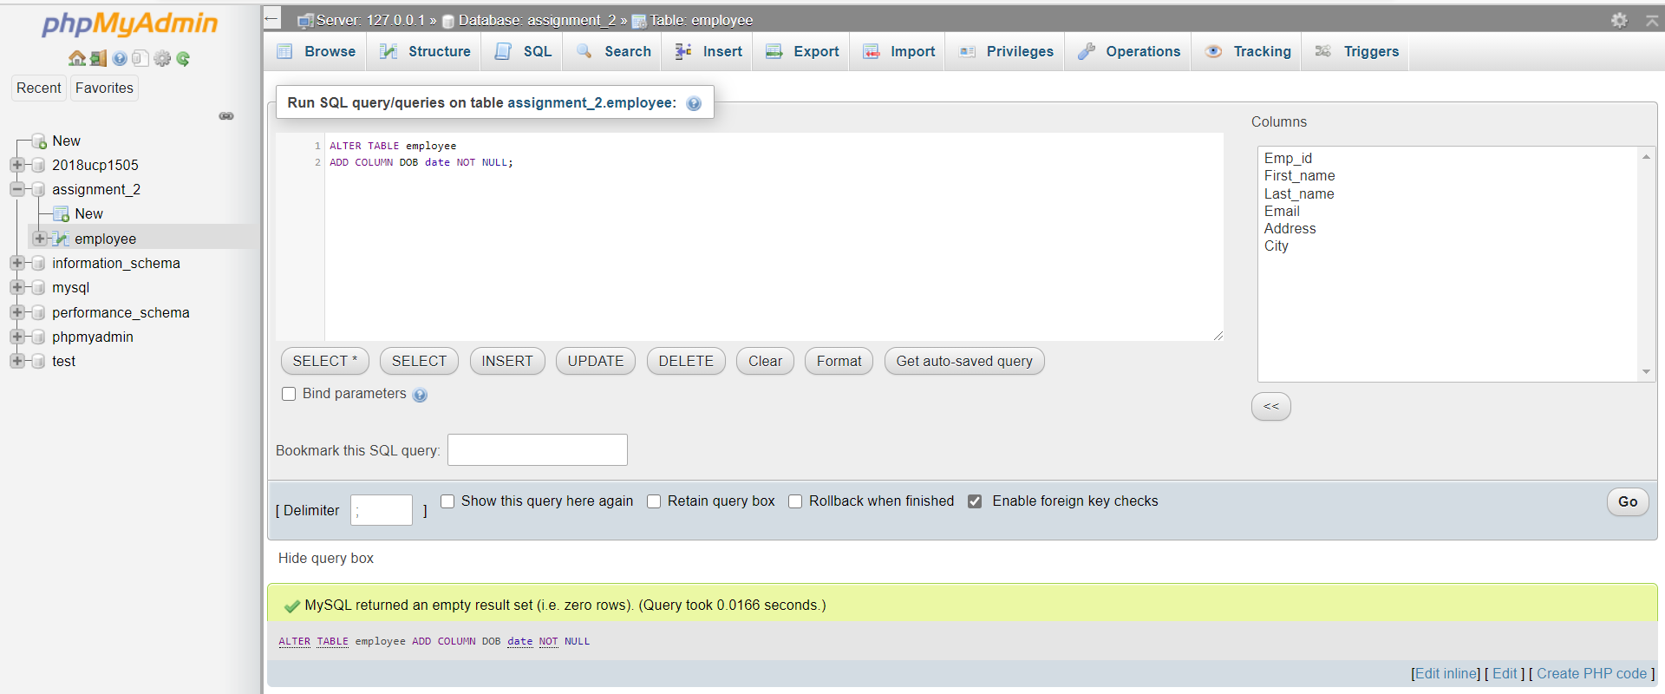

Q5: WAQ to make the "Emp_id" column as the primary key in the Employee table.

Ans:

Query: -

ALTER TABLE Employee

ADD PRIMARY KEY (Emp_id);

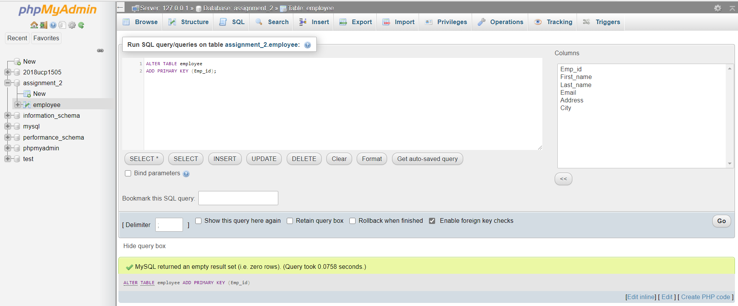

Q6: WAQ to delete Employees who do not have a joining date. (i.e. joining date is null).

Ans:

DATABASE BEFORE EXECUTING QUERY: -

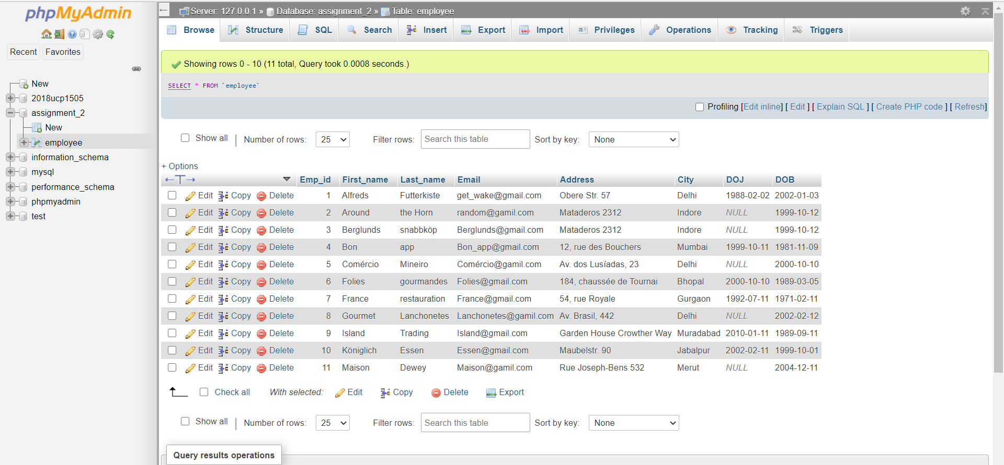

QUERY: -

DELETE DROM ‘employee’ WHERE DOJ is NULL;

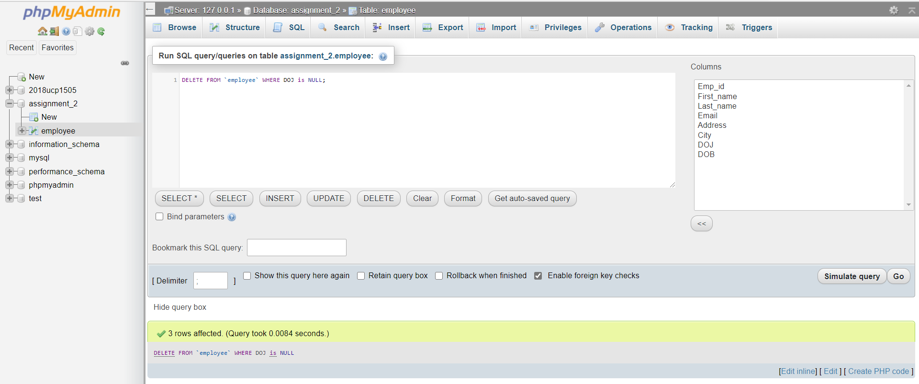

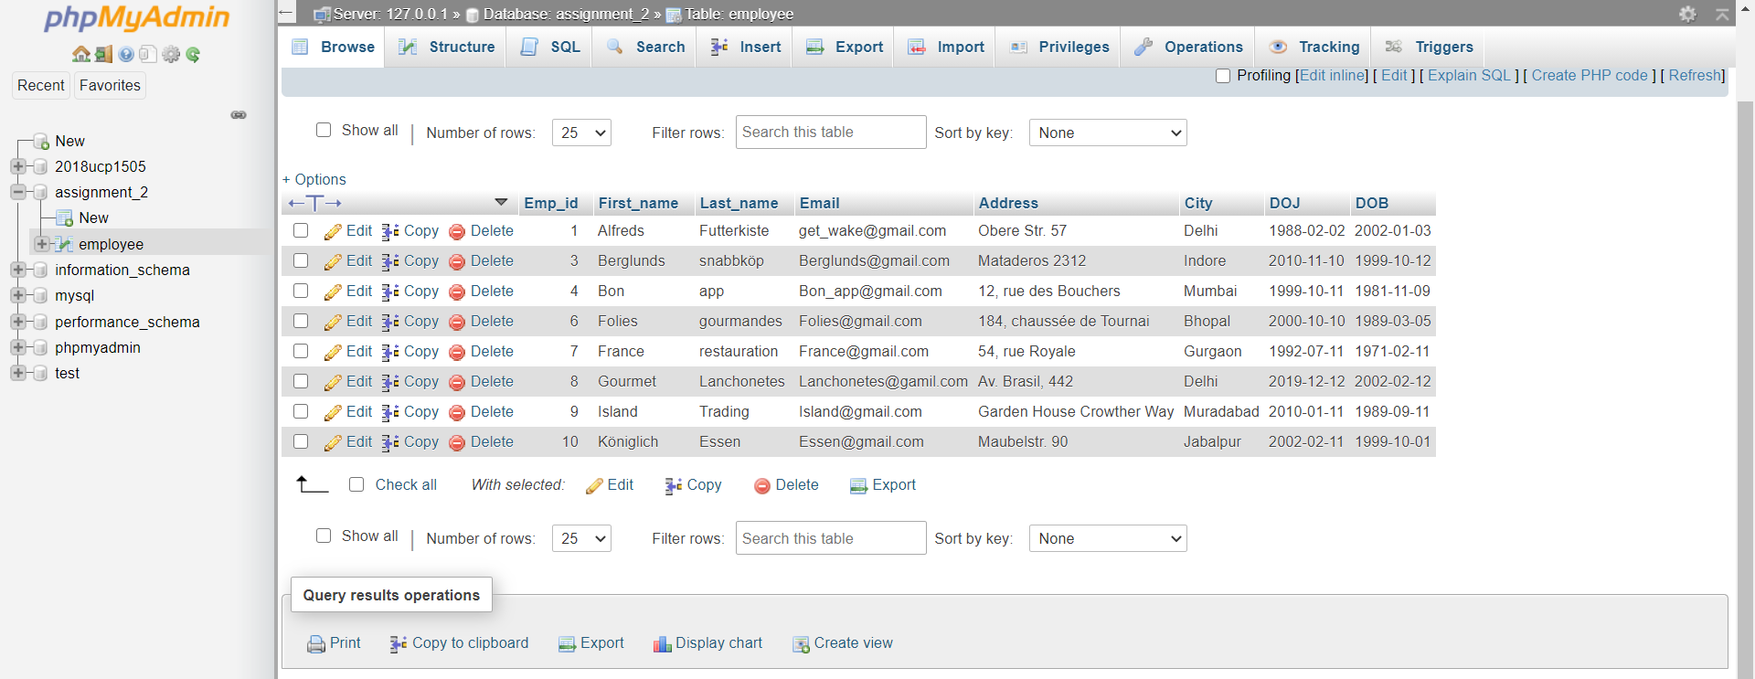DATABASE AFTER EXECUTING QUERY: -

Q7: WAQ to update all records where the city is "Delhi" to city "Gurgaon".

Ans:

DATABASE BEFORE EXECUTING QUERY: -



Query: -

UPDATE ‘employee’

SET City = ‘Gurgaon’

WHERE City = ‘Delhi’

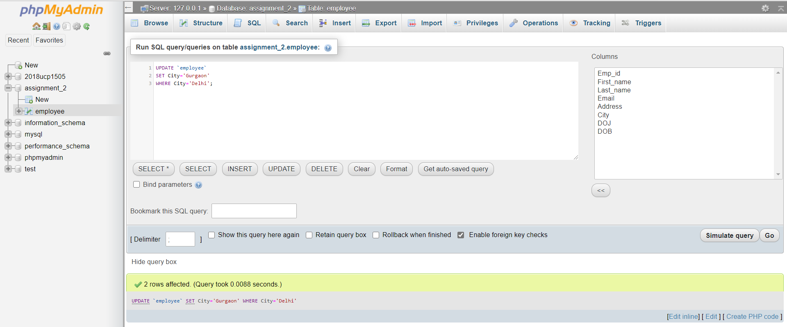

DATABASE AFTER EXECUTING QUERY: -

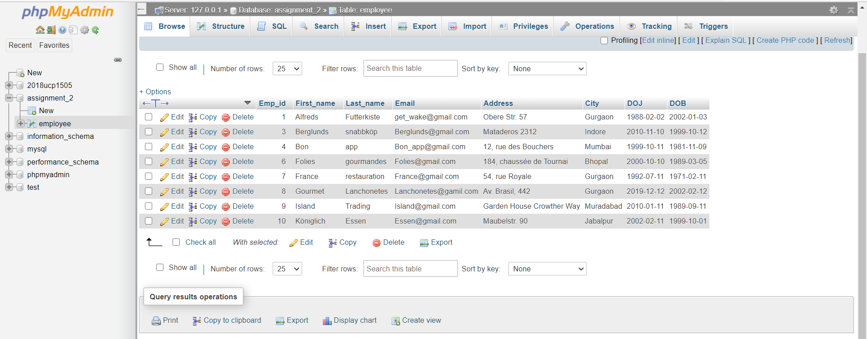

Q8: WAQ to remove all records from the table.

Ans:

DATABASE BEFORE EXECUTING QUERY: -



Query: -

DELETE FROM ‘Employee’;

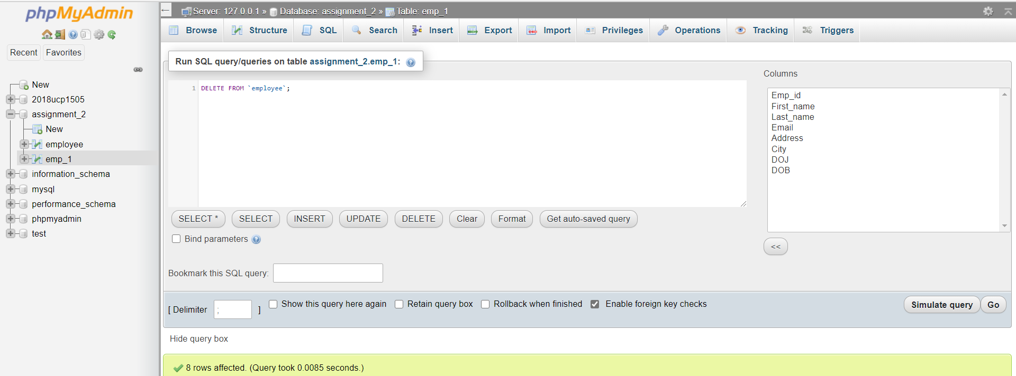

DATABASE AFTER EXECUTING QUERY: -

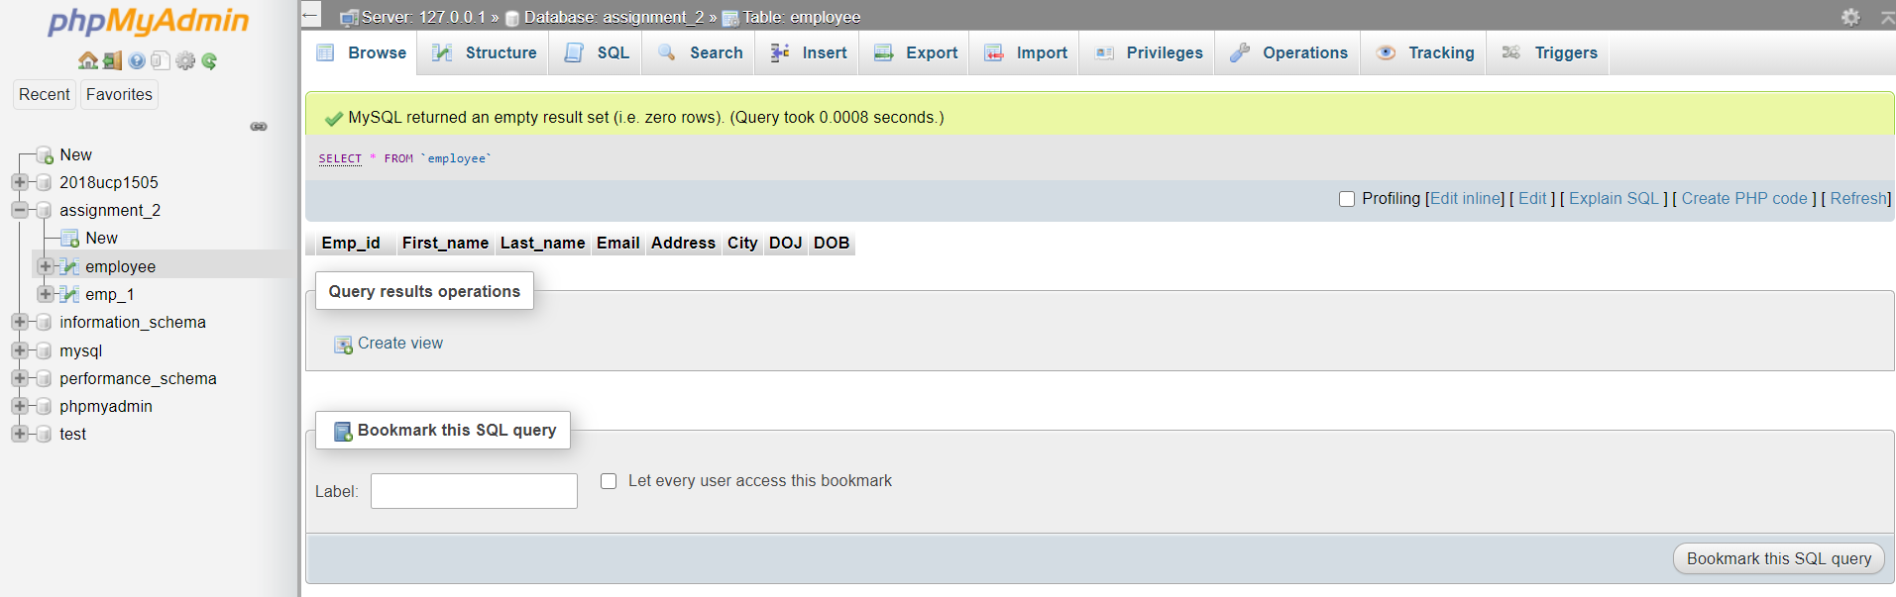

Q9: WAQ to rename Employee table to Emp_1.

Ans:

Query: -

ALTER TABLE employee

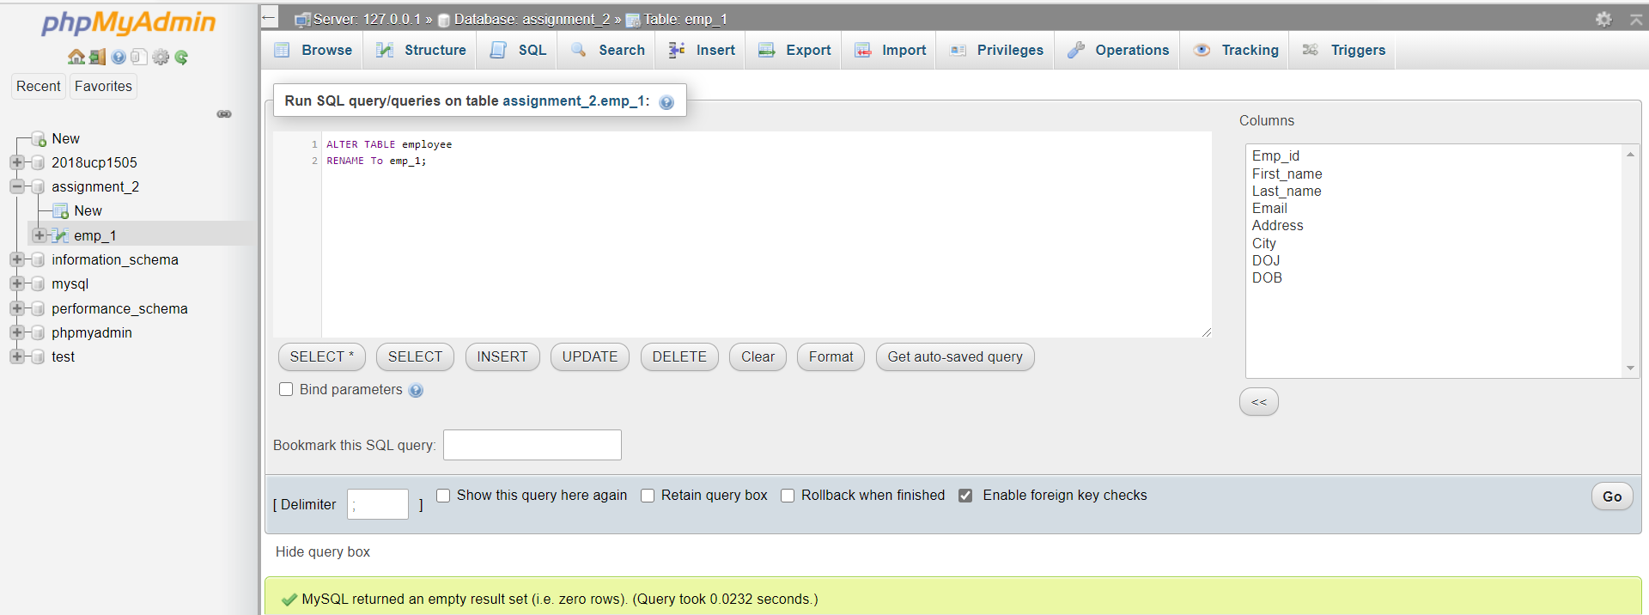RENAME TO emp_1;

Q10: Insert new records in the Emp_1 table. Then WAQ to completely delete Emp_1 table (i.e. delete data as well as structure of table from the database).

Ans:

Query: -

INSERT INTO ‘emp_1’ (‘Emp_id’,’First_name’,’Last_name’,’Email’,’Address’,’City’,’DOJ’,’DOB’)

VALUES (11,’Anurim’,’Gesture’,’gesture@gmail.com’,’Delhi’,’2010-11-11’,’2000-1-1’);

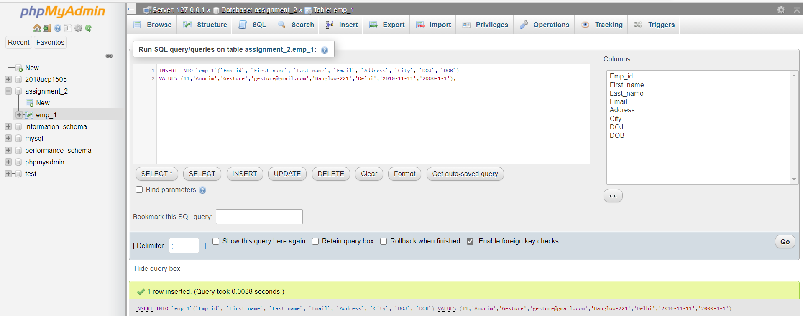

DROP TABLE employee;

